**UNIVERSITY OF MUMBAI**



**Master of Computer Application**

**Mini Project Report on**

Factogram.AI Chatbot

**Submitted by**

Ansari Amaan Asrar Ahmed (02)

(Semester- 2nd)

Year 2023-25

Under the Guidance of

Dr Vinita Gaikwad, Prof Anamika Dhawan

----------------------------

Faculty In-charge

|  |  |  |
| --- | --- | --- |
| Sr No. | Module | Detailed Contents |
| 1. | Introduction | ●Introduction of the Project(SRS)  ●Problem Definition  ●Objective of Project  ●Scope of Project |
| 2. | System Study | ●Existing System  ●Disadvantages of Existing System  ●Proposed System  ●Use Cases |
| 3. | Analysis & Validation | ●Software/Hardware Requirement Specification  **-**Software Requirement  **-**Hardware Requirement  ●GANTT Chart  ●UML Diagram  ●Module Design & Organization |
| 4. | Testing & Validation | ●Test Cases & Report (based on manual & automation techniques) |
| 5. | User Manual | ●Explanation of Key Functions  ●Method of Implementation  **-**Output Screens |
| 6. | Conclusion | ●Project Conclusion & Future Enhancement |

**Introduction:**

**Introduction of the project:**

The Factogram.AI Chatbot project is an innovative educational tool designed to make learning engaging and interactive for 4th-grade children. Leveraging the power of natural language processing and user-friendly conversational interfaces, the chatbot provides a unique learning experience, fostering curiosity and knowledge retention.

**Key Features:**

**● Conversational learning:** Children can ask questions and engage in a dialogue with the chatbot.

● **Question and Answer Functionality:** The chatbot can answer user questions on a variety of general knowledge topics.

● **User-Friendly Interface:** The chatbot offers a simple and intuitive interface suitable for 4th-grade students.

**Problem Definition:**

Traditional methods of teaching GK to children often face challenges in maintaining engagement and catering to diverse learning styles. Textbooks and lectures may not fully capture the attention of 4th-grade students, leading to a gap in knowledge acquisition. The project addresses these challenges by introducing an interactive GK chatbot that aligns with the interests and learning preferences of young students.

**Challenges:**

● Lack of engagement in traditional learning methods.

● Difficulty in providing personalized learning experiences.

● Limited accessibility to interactive GK resources for children.

**Objectives:**

The primary objectives of the GK Chatbot project are as follows:

**● Enhanced Learning Experience:**

Create a chatbot that fosters curiosity and excitement about general knowledge topics among 4th-grade children.

**● Personalized Learning:**

Tailor the chatbot's responses to the individual learning levels and interests of each child.

**● Interactive Quizzes:**

Integrate gamification elements, such as quizzes and rewards, to make the learning process enjoyable and motivating.

**● Accessible Education:**

Provide a user-friendly and accessible platform that children can engage with outside traditional classroom settings.

**Scope:**

The scope of the GK Chatbot project encompasses the following:

**● Chatbot Development:**

Design and implement a chatbot capable of understanding queries related to general knowledge topics.

**● Intents and Responses:**

Develop a comprehensive set of intents and responses to cover a diverse range of GK topics.

**● User Interface:**

Create a user-friendly interface that encourages interactive conversations and quizzes.

**System Study:**

**Existing System:**

● **Traditional Educational Methods:**

The current system predominantly employs traditional educational methods, relying on textbooks, classroom lectures, and printed materials for teaching general knowledge to 4th-grade students.

● **Limited Interactivity:**

Educational materials in use have minimal interactivity, with a focus on static content delivery rather than dynamic and interactive learning experiences.

● **Uniform Content Delivery:**

The existing approach follows a standardized and uniform content delivery model, providing the same learning materials to all students without considering individual learning styles or preferences.

● **Resource Accessibility Challenges:**

Students face challenges accessing diverse and interactive general knowledge resources outside of the classroom, leading to limitations in exposure to engaging learning materials.

**Disadvantages of Existing System:**

● **Traditional Educational Methods:**

The current system relies on traditional educational methods, such as textbooks and lectures, for teaching general knowledge to 4th-grade students.

● **Limited Interactivity:**

Educational materials lack interactivity, making it challenging to capture the attention and engagement of young learners in the digital age.

● **One-Size-Fits-All Approach:**

The existing approach tends to follow a one-size-fits-all model, not accounting for the diverse learning styles, preferences, and paces of individual students.

● **Limited Accessibility to Resources:**

Students may face challenges accessing diverse and interactive general knowledge resources outside of the classroom, limiting their exposure to engaging learning materials.

● **Potential Disengagement:**

Monotonous delivery methods and a lack of interactive elements may contribute to potential disengagement among 4th-grade students, affecting their overall learning experience.

● **Minimal Use of Technology:**

The current system minimally incorporates technology, missing out on the opportunities presented by advancements in artificial intelligence and natural language processing.

**Proposed System:**

● **AI Chatbot:**

Implement an advanced AI chatbot as the core of the proposed system, utilizing AI to engage 4th-grade students in interactive and dynamic conversations.

● **Continuous Learning Opportunities:**

Facilitate continuous learning opportunities beyond traditional classroom hours, allowing students to explore general knowledge topics at their own pace and convenience.

**Analysis & Design:**

**Software Requirement:**

● **Programming Language:**

Python

●**Natural Language Processing (NLP):**

NLTK for NLP

● **Integrated Development Environment (IDE):**

Visual Studio Code

**Hardware Requirement:**

● **Processor:**

Minimum: Dual-core processor, Recommended: Quad-core processor.

● **RAM:**

Minimum: 4 GB.

Recommended: 8 GB or higher.

● **Storage:**

Minimum: 256 GB HDD/SSD.

● **Network:**

Internet Connectivity: Required for library installations.

● **Display:**

Resolution: Minimum 1280x800 pixels.

● **Input Devices:**

Keyboard and Mouse: Standard input devices.

● **Operating System:**

Windows: Windows 10 or latest.

**GANTT Chart:**

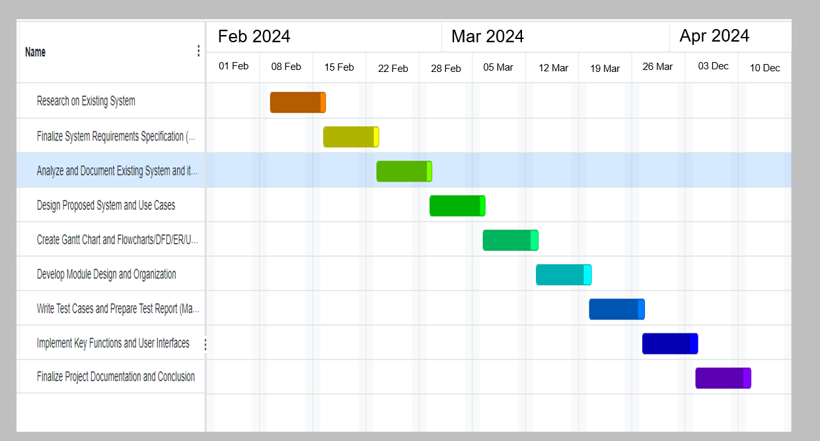

**Diagram:**

**Use Case Diagram:**

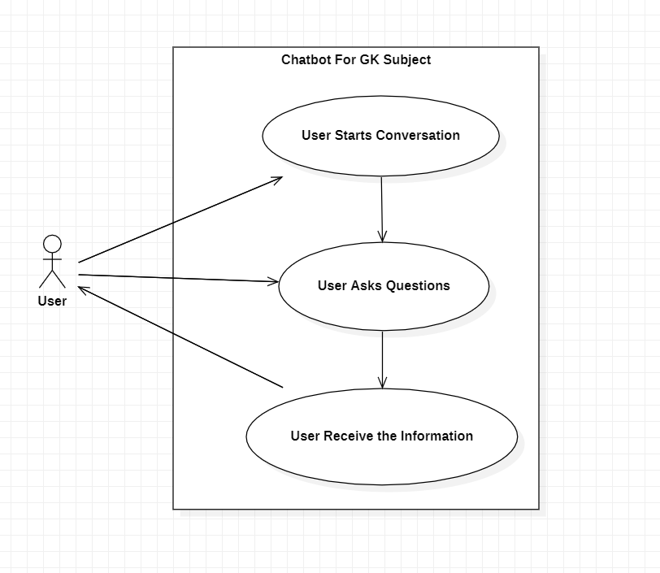

**Sequence Diagram:**

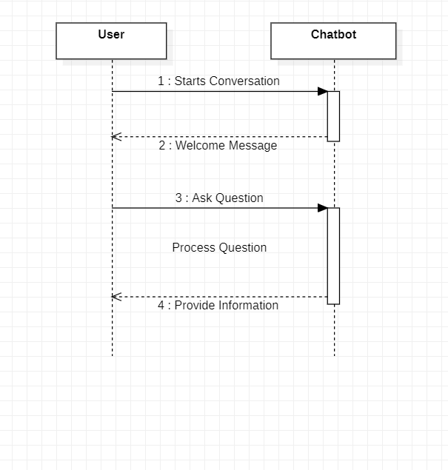

**Activity Diagram:**

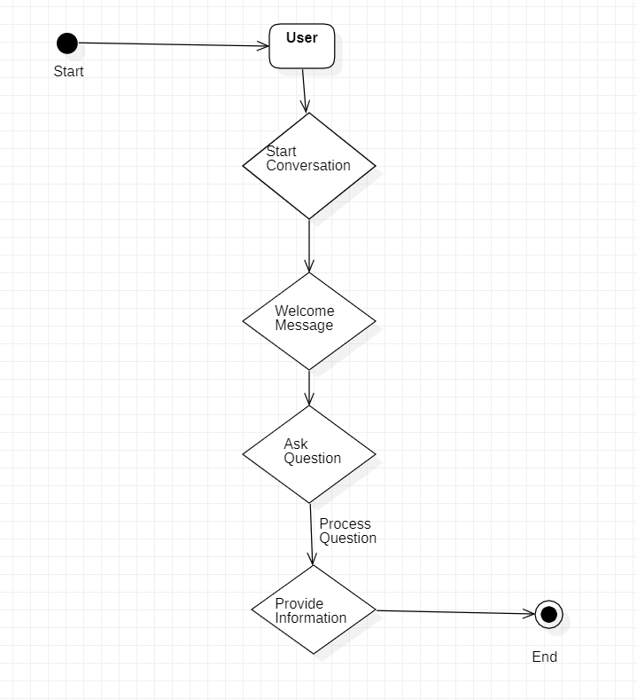

**Module Design & Organization:**

● **Chatbot Engine Module:**

**-** Responsible for handling user input, processing queries, and generating appropriate responses.

**-** Includes integration with ChatterBot library for chat functionality.

**-** Manages conversation flow and context.

● **NLP Processing Module:**

**-** Integrates with NLTK for natural language processing.

**-** Processes user queries to extract intents, entities, and context for more accurate responses.

**-** Enhances the understanding of user input.

● **Data Management Module:**

**-** Manages the intents.json file containing predefined intents and responses.

**-** Reads and parses the JSON file to retrieve data for training and responding to user queries.

**-** Handles updates and modifications to the dataset.

● **Intent Training Module:**

**-** Handles the training of the chatbot based on the data provided in the intents.json file.

**-** Trains the ChatterBot model to improve accuracy and relevance in responses over time.

**Testing & Validation:**

**Test Cases:**

|  |  |  |
| --- | --- | --- |
| Input | Expected Result | Actual Result |
| Start a conversation | Chatbot greets and engages. | Chatbot greeted and engaged successfully |
| Ask varied intent questions | Correct identification and responses | Accurate identification and relevant responses |
| Input questions with variations | Accurate processing and understanding | Successful processing of different language variations |
| Ask educational questions | Retrieve accurate info from `intents.json` | Precise and relevant information retrieved |

**User Manual:**

**Explanation of Key Functions:**

**Chatbot Interaction:**

The core function involves user interaction with the chatbot. Users can ask questions, seek information, or engage in conversations to enhance their knowledge.

**Natural Language Processing (NLP):**

NLP is employed to enhance the chatbot's ability to understand and interpret user input. This includes extracting intents and entities from user queries for more accurate responses.

**Educational Content Retrieval:**

The chatbot retrieves educational content from the predefined intents.json file. This file contains a structured set of intents and responses related to general knowledge relevant topics.

**Method of Implementation:**

**Project Planning:**

Defining clear objectives, scope, and features of the GK Chatbot project.

Creating a timeline and allocating resources for development.

**Technology Stack Selection:**

Choosing the programming language (Python), frameworks and libraries (NLTK for NLP) based on project requirements.

**Data Collection:**

Gather educational content and structure it into intents and responses in a intents.json file.

**Natural Language Processing (NLP) Integration:**

Implement NLP components using NLTK to process user queries and extract intents and entities.

**-Output Screen:**

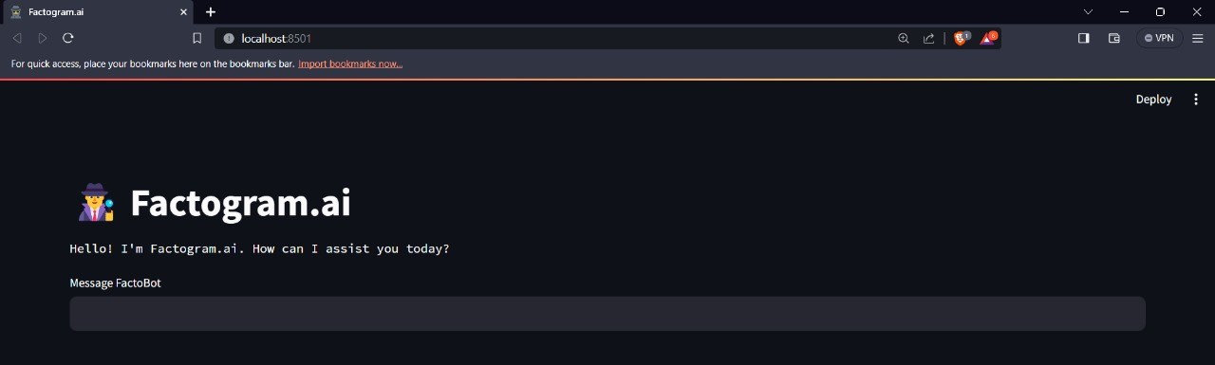

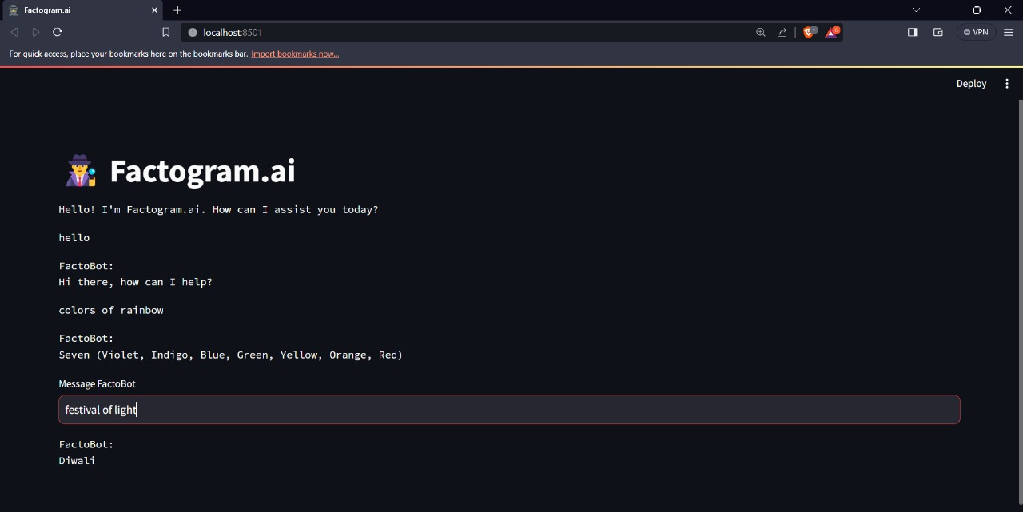

**Conclusion**

**Conclusion:**

**Project Success:**

The General Knowledge Chatbot project has successfully delivered on its objective - creating an interactive learning tool tailored for 4th-grade students.

**Engaging Learning Experience:**

We implemented chatbot, fueled by natural language processing and enriched with content from the intents.json file, ensures an engaging and accessible learning experience.

**Overcoming Challenges:**

We faced and conquered various challenges, showcasing the team's resilience and problem-solving skills.

**Positive Impact:**

This conclusion marks the completion of a project aimed at making a meaningful impact on education, providing 4th-grade students with an exciting and interactive learning journey.

**Future Enhancement:**

**Interactive Dashboard:**

Designing an interactive dashboard that provides users with a visually appealing and intuitive interface. Include a personalized learning journey to users.

**GUI Navigation (Future Enhancement):**

As part of future enhancements, the introduction of a graphical user interface (GUI) will provide users with a visual and interactive platform for a more engaging learning experience.

**Dynamic Learning Paths (Future Enhancement):**

The GUI will incorporate dynamic learning paths, adjusting content presentation based on user interactions and preferences for a personalized learning journey.

**Multimedia Integration (Future Enhancement):**

Future developments aim to include multimedia elements, such as images and videos, to enhance the educational experience and cater to different learning styles.